## SPECIFIC AIMS

Probiotic research has come to encompass key areas of disease, ranging from infections1–3 to cancer treatment4–9. The effect of the microbiome on health is now undeniable, and every year in the US over 400,000 people collectively spend $1 billion dollars on over-the-counter probiotics intended to alter their microbiome. Unfortunately, despite the many links between the microbiome and health, our ability to design more broadly effective probiotics has been largely unsuccessful10,11. This is because current probiotic interventions are typically viewed as a simple addition—i.e., intake of a microbe, while efficacy of a probiotic is determined by *ecological principles*12–14.

In order to achieve the desired effects in the gut microbial community, the design of probiotics require an *ecologic approach* that encompasses the principles of microbial metabolism15–18, ecological succession19–21, and host-microbe interactions22–25. A mechanistic, personalized approach to probiotic design has the potential to propel the field forward. *To this end, we propose a 3-step pipeline for rational probiotic design; starting with a metagenomic data set, this pipeline systematically identifies the most promising probiotic candidates and then subjects them to a series of increasingly rigorous tests by employing an in-silico-to-in-vivo axis of exploration*.

The pipeline’s key innovations are the use of metabolic interaction data to characterize important ecologic features of disease-associated microbiomes, such as underutilized nutrients (dysbiosis), engraftment potential, and stability. As part of these assessments, we will rely on community metabolic modeling, bioreactor multi-omics data, and testing in mice with defined microbial communities. Our proposed objective is to demonstrate the pipeline’s promise by applying it to a single test case: *Clostridium difficile* (*C. diff*) prevention. Specifically, we will carry out the following steps:

**Step 1: Identify microbial species can engraft and prevent the *C. diff* growth using a sum-of-interactions approach**22,26**.** By pairing metabolic interaction data with microbiome profiles from *C. diff*-susceptible subjects, we will construct **interaction landscapes** that identify which microbes can successfully compete with *C. diff***,** thus closing its ecologic niche in the gut**,** and **niche landscapes** that identify which of these microbes are capable of engrafting in a given microbiome, a prerequisite for effectiveness.

**Step 2: Analyze the ability of potential probiotics to engraftment long-term and provide a stable microbiome through comparisons of *in silico* and *in vitro* testing.** Interventions that alter the microbiome, such as probiotics, result in a shifting fitness landscape that may lead microbial communities to depart from the predictions made in Step 1. We will dynamically simulate probiotic persistence and *C. diff*-susceptibility using metabolic models27 enhanced by shallow metagenomics, transcriptomics, and metabolomics data taken from stool bioreactors.

**Step 3: Validate *in silico* predictions using a germ-free mouse model.** In this last step, we will test the ability of the top 5 probiotic candidates from Step 2 to prevent *C. diff* infection in a germ-free mouse model humanized with paired *C. diff*-susceptible microbiomes24,25.

By applying the pipeline to the clinically pressing, microbiome-linked problem of pathogen control, we intend to demonstrate this strategy’s value and also to refine the pipeline for future use. Although we focus here on *C. diff* as a test case, the pipeline is flexible and designed to identify probiotic solutions for preventing disease conditions such as colorectal cancer, which has been linked with multiple pathogens22,28–31. If validated, this pipeline has the potential to fill a fundamental knowledge gap by providing information on the biological mechanisms and trends that link the microbiome to diverse health outcomes, while also providing a practical payoff: probiotics capable of addressing otherwise intractable health problems. *In short, the fundamental value of the pipeline is that it will allow researchers to exploit the wealth of existing metagenomic data sets by translating raw sequence data into empirical predictions about the microbes most likely to promote health*.

## SIGNIFICANCE

More and more diseases, representing some of the country’s greatest health threats (Table 1), continue to be linked to dysbiosis of the gut microbiome. This has sparked enormous enthusiasm among patients and in the consumer market. In fact, each year Americans spend more than $1 billion on probiotics. Despite the public’s enthusiasm for probiotics and the considerable resources devoted to probiotic research, the NIH’s National Center for Complementary and Integrative Health currently states that the benefits of probiotics “have not been conclusively demonstrated”32.

|  |  |
| --- | --- |
| Disease/disorder | Estimated cases, US |
| *C. difficile* infection | Annually: 453,000 cases, 29,000 deaths |
| Colorectal cancer | Annually: 1.2 million cases, 50,000 deaths |
| Diabetes | 22 million |
| Inflammatory bowel disease | 1.4 million |
| Irritable bowel syndrome | 24 to 36 million |
| Multiple sclerosis | 400,000 |
| Obesity | 89 million |
| Autism | 3.2 million |

**Table 1.** Select diseases and disorders linked to dysbiosis of the gut microbiome

Scientifically, enthusiasm derives largely from a set of experiments where altering the microbiome can lead to dramatic effects on disease incidence or resistance33–36. These experiments are typically carried out in an animal model where one has strong experimental control over the resident gut microflora—for instance, germ-free mice undergoing some type of microbial gavage. Importantly, these germ-free mice have no native microflora and the dramatic effects seen in these animal models show us the potential of probiotics when we have idealized control over alterations to the microbiome.

The difference between an idealized animal model and human probiotic trials are stark. Results of a recent meta-analysis of clinical trials in healthy adults found no evidence that currently used probiotics are even capable of modifying the composition of the gut microbiome37. Studies of short and long-term probiotic use show that more than 2/3 of trial subjects show no long-term alterations in the microbial composition of their gastrointestinal (GI) tract10,12.

More recently, there have been attempts to systematically evaluate the ecologic properties that limit the ability of most microbes to inhabit our bodies13,19. Given the importance of the existing microflora on a probiotics ability to engraft, the past difficulty with widespread probiotic efficacy are unsurprising.

Successful probiotic design requires **a detailed roadmap for reaching the target microbiome**. The pipeline described here is significant because instead of working backward from statistical associations to probiotic interventions, it moves forward along the causal axis, using microbe-microbe interactions to make predictions about microbial ecological drivers.

This also means that our pipeline is able to **account for the personalized nature of the microbiome**. The microbiome also varies between individuals, and these varying ecologic contexts must be considered when crafting probiotic solutions. Although the target microbiome may not vary (in this case, the target being a *C. difficile*-resistant microbiome), the path to that target, i.e., the probiotic therapy required, must take into account differences in an individual’s starting microbiome to be effective.

Once validated, this test system will represent *the first complete pipeline for mechanistic probiotic design*. Although this proposal focuses on *C. difficile-*susceptibilityas an initial test case, with simple adjustments our framework can be applied to various pathogens, such as those known to cause cancer38 or enhance tumor resistance39. Our pipeline is designed to produce personalized probiotic solutions, and eventually the effectiveness of these solutions can be tested in adaptive clinical trials or by using aggregated data from *N*-of-1 trials. If this pipeline works as planned, it could help put the United States on track to meet some of its most ambitious national health goals, including significantly reducing the number of hospital-acquired infections and preventing cancer.

## INNOVATION

*The proposed pipeline represents the first computational approach to probiotic design based on mechanistic principles.* To build a model that predicts a microbial community’s response to a probiotic, we must encapsulate the most potent interactions driving microbial ecology—nothing more and nothing less. Microbe-microbe cooperative/competitive interactions are the natural focus when seeking to understand changes in the species composition of the microbiome. Indeed, our preliminary data (*described below*) indicates that models based on these interactions are capable of capturing the critical threshold between pathogen invasion and ecological resilience. By starting with the basic ecologic building blocks of microbe-microbe interactions, which are driven primarily by microbial metabolism, we expect to generate accurate predictions regarding the gut microbial community’s composition, resilience, and functions.

*The proposed pipeline explicitly considers the role of microbe-microbe interactions in microbial engraftment and long-term efficacy.* Step 1 of our pipeline includes a baseline survey of the landscape of metabolic interactions; it uses metabolic modeling to inform us of the ability of a given probiotic to grow (i.e., engraft) within a particular microbial community. Step 2 augments these models of the microbe-microbe interactions by matching dynamic flux-balance analysis (dFBA) parameters with metagenomics, transcriptomics, and metabolomics data from time-longitudinal stool bioreactors. DFBA has been used in simpler systems to successfully predict ecologic dynamics40. Here it is used to ensure that we capture the long-term effect of introducing a probiotic, in particular its ability to persist.

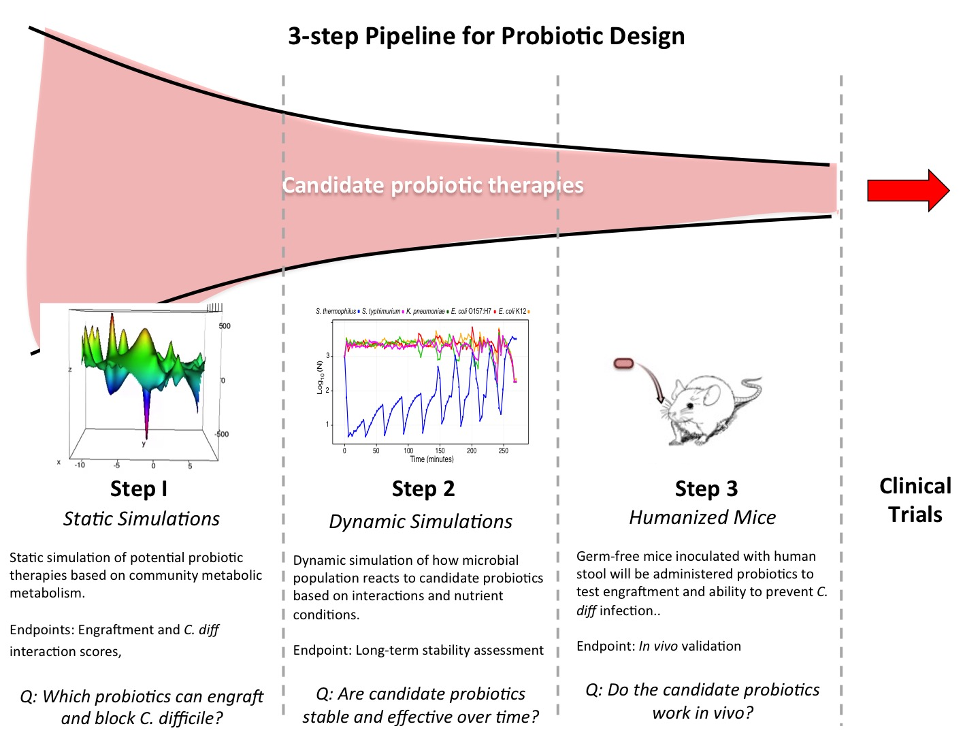

**Figure 1.** Diagram of our 3-stage pipeline for identifying promising probiotics**.**

Finally, our pipeline’s the sieve structure of the design engine moves probiotics from a series of mechanism-based computational approaches to an *in vivo* test in Step 3. Our approach starts by assessing the probiotic potential of *all* culturable microbes. It continues all the way through pre-clinical testing by following high-throughput, first-pass computational predictions with *in vivo* experiments. Thanks to its ability to transform omics data into actionable information, we expect this innovative system to substantially increase productivity across the field of probiotic design.

## INVESTIGATORS

The Microbiome Program within the Center for Individualized Medicine at Mayo Clinic is uniquely resourced to perform all necessary theoretical and experimental work. It one of a few major microbiome centers around the country and one that combines with a strong theoretical focus—as exemplified in the faculty hire of PI Chia—and with an available in-house Germ Free Facility. PI Chia leads the bioinformatics, modeling, and systems biology division of the Microbiome Program. Building upon his combined expertise in modeling ecological population dynamics and metabolic modeling provides the core expertise required for steps 1 and 2 of this proposal. Co-I Ridlon provides microbial expertise for stool bioreactors experiments. Co-I Kashyap leads the clinical trial and germ-free infrastructures within the Microbiome Program. In addition, his expertise in *C. difficile* and animal testing, he provides the expertise for required for step 3. Overall, this team represents a unique combination of strengths and resources for successfully realizing the proposed pipeline for probiotic design.

## APPROACH

Specific Aim: Establish a pre-clinical testing pipeline for probiotics, using prevention of C. diff infection as a test case.We have decided to use *C. diff* prevention as a test case for our pipeline for several reasons. First, *C. diff* is the most frequent cause of healthcare-associated gastrointestinal illness, which is responsible for billions in medical costs annually. Second, antibiotics, our go-to treatment for bacterial infections for decades, are of limited use against this infection. Although fecal transplants are now an accepted therapy for *C. diff* infections that do not respond to antibiotics, practicing such treatment on a large scale remains difficult. Thus, *C. diff* susceptibility remains a problem in need of a solution. Third, we have access to metagenomic data from *C. diff*-susceptible and *C. diff*-non-susceptible metagenomes25. Fourth, a mouse model of *C. diff* susceptibility exists. Finally, and crucially, *C. diff* prevention represents a relatively simple ecologic problem that is ideal for testing our new pipeline: it requires us to exclude one pathogen by blocking one niche.

### Rationale for building our pipeline on a foundation of metabolic interactions

As described in the Innovation section, our pipeline is built on the assumption that interactions between microbes determine higher levels of assembly within the microbiome, governing critical phenomena such as microbe engraftment or extinction41–43. We focus in particular on metabolic interactions, as they determine in large part whether 2 microbes cooperate or compete with one another.

In the test case we have selected, pathogen exclusion, our assumption about the centrality of metabolic interactions in determining the composition of the microbiome appears to be well supported41,44. First, to sustain themselves, pathogens depend on metabolites produced by other microbes44. For example, in mice, *C. diff* and *Salmonella typhimurium* both exploit the sialic acid produced by the bacterium *Bacteroides thetaiotaomicron* to gain a growth advantage over existing community members45. Second, invading pathogens use metabolites produced by other microbes as chemical signals. For instance, enterohemorrhagic *Escherichia coli* uses fucose to determine that it has arrived at the correct place in the gut and adjust its metabolism and virulence gene expression accordingly46. These findings on the importance of metabolic interactions in pathogen invasion have led to the idea that we can develop effective probiotics by identifying microbes that compete with potential pathogens.

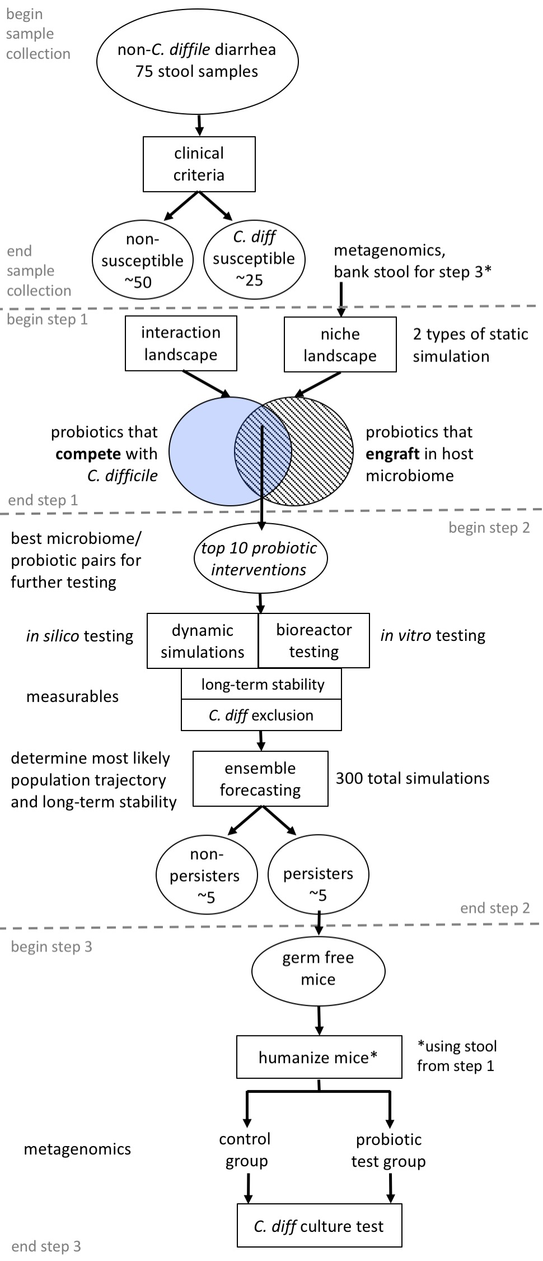**Figure 2.** Detailed schematic of the methods used in each of this proposal’s 3 steps to identify probiotics capable of excluding *C. diff.*

Proof-of-principle for the competitive exclusion approach exists. *S. typhimurium* requires iron to persist in the host; thus, it scavenges for iron in the inflamed host gut. Deriu et al.47 were able to identify another gut microbe that scavenges for iron in the same way but does not cause disease: *E. coli* strain Nissle 1917. When they administered a single dose of the Nissle strain to mice with existing *S. enterica* infections, the strain was able to establish persistent colonization, outcompete *S. enterica*, and thus reduce the pathogen burden. Thus, *in vivo* evidence that one microbe can be used to exclude another already exists, which is encouraging for researchers working on probiotic design.

Although these results are promising, the field currently lacks a systematic way to evaluate microbe-microbe interactions and identify promising probiotics. In the study described above, the Nissle strain was selected because it was readily available and relatively well characterized. But we know little about most microbes in the human gut; without evaluating the promise of little-known bacteria as well, it seems unlikely that the search for effective probiotics will proceed efficiently. One recent modeling study of the gut microbiome suggests that by manipulating strongly interacting species—those with very strong impacts (either negative or positive) on the species that they directly interact with—we can alter the steady state landscape of the microbial community and steer it toward desired community types48. Importantly, these strongly interacting species need not be among the most abundant in the community. *A mechanistic approach to selecting probiotics may unlock the promise of this approach to promoting health, by identifying influential species that can cause long-lasting changes in the composition of the gut microbiome—changes that exclude pathogens*.

### Research Design

**Figure 2** represents a schematic of the 3-step design of the proposed research.

#### Sample Collection

Briefly, 75 human stool samples will be gathered from Mayo Clinic patients >18 years old who present with diarrhea at the Mayo Clinic’s Irritable Bowel Syndrome Clinic and test negative for *C. diff*, *Shigella, Salmonella, Campylobacter jejuni/coli, Escherichia coli,* and *Yersinia* (Mayo Clinic Test ID EPFRP). All individuals will be voluntarily enrolled in this study (continuation of IRB #12-007176). Upon receiving written consent from participants, frozen stool remaining after clinical testing will be obtained and stored at -80°C. Based on our previous results, we expect roughly one-third of the subjects to be *C. diff*-susceptible25.

|  |  |
| --- | --- |
| A | B |

**Figure 3**. *C. diff* engraftment score predicts host susceptibility. (A) Engraftment scores predict a positive interaction with *C. diff* in *C. diff*-susceptible microbiomes and less cooperative interaction in *C. diff*-non-susceptible microbiomes. (B) In mice humanized with non-susceptible microbiomes, *C. diff* was rejected by day 6; in mice humanized with susceptible microbiomes, *C. diff* remained established.

#### Step 1: Conduct static simulations to identify which microbial species can prevent C. diff from becoming established in the gut.

The static simulations in Step 1 will be used to construct 2 landscapes that identify the most promising probiotic candidates—an interaction landscape and a niche landscape that together describe a microbial species role in *C. diff*-resistance and engraftment potential. Preliminary results from germ-free mice confirm that our engraftment scores accurately reflect theability of *C. diff* to invade the gut microbiome and persist. To test our engraftment predictions, we humanized 20 germ-free mice with either *C. diff*-susceptible (*n*=2) or non-susceptible (*n*=2) stool samples gathered from patients with diarrhea. We then challenged the mice with *C. diff* 4 weeks later(Fig. 3). The mice with non-susceptible microbiomes rejected the *C. diff* challenge completely within 6 days, whereas the mice with susceptible microbiomes displayed a high *C. diff* load (Fig. 3). *Thus, by summing microbe-microbe metabolic interactions in a static simulation to produce an engraftment score for a pathogen, we can accurately predict the susceptibility of a microbiome to invasion by that pathogen*. We expect the engraftment score to be equally informative about the ability of probiotics to engraft.

In order to do this, first we will construct an **interaction landscape** to identify which probiotic candidates can close *C. diff*’s ecological niche. Using pairwise metabolic interaction data, we will assess the ability of each organism in the human culture collection to compete with *C. diff*. Positive interactions represent cooperation and negative interactions represent competition, so organisms with the lowest interaction scores will be good candidates for excluding *C. diff* (Fig. 4).

Next, we will construct a **niche landscape** to identify which probiotics are capable of engrafting within the *C. diff*-susceptible microbiome. Here, we will use metabolic interaction data to assess the ability of each organism in the human culture collection to persist in the 25 *C. diff*-susceptible microbiomes gathered from the Mayo Clinic (Fig. 4). Briefly, the target organism’s net interactions with each microbe in a given microbiome will be calculated, to yield the niche landscape, where, with each microbe in a given microbiome will be calculated, to yield the niche landscape, where, as described above, positive interactions represent cooperation and negative interactions represent competition. From a composite score that encompasses both the engraftment and *C.diff*-interaction scores, we will identify the 10 most promising probiotic-microbiome pairs (i.e., those with the highest engraftment scores and most negative *C. diff*-interaction scores). These pairs will progress to Step 2.

|  |  |
| --- | --- |
| A | B |
| C | D |

**Figure 4**. With 2 scores, we can predict an organism’s ability to exclude *C. diff* (*top*) and engraft within the microbiome (*bottom*). (A) Represents a cross-section of the **interaction landscape**. Promising probiotics have a low ***C. diff*-interaction score**, indicating a high level of metabolic competition with *C. diff*. The interaction score, $α_{ij}$, for each individual species, $m$, with *C. diff* (species x) is calculated:

$α_{xm}\text{=}{\text{g}}^{\text{x}}\left(\text{xm}\right)\text{-}{\text{g}}^{\text{x}}\text{(x)}$,

where $g^{x}\left(x\right)$ is the growth rate of $x$ alone, and $g^{x}\left(xm\right)$ is the growth rate of $x$ in a community composed of both $x$ and $m$. (B) Represents a cross-section of the **niche landscape**. Here, we measure the ability of probiotics to engraft within a given microbiome. Candidate probiotics that have the highest **engraftment scores** are the most likely to engraft. The engraftment score, $I$, for an individual probiotic species, $m$, and microbiome community members $j=j_{0}…j_{q}$ is calculated thus:

$I_{j}^{m}=\sum_{i=0}^{q}{α_{mj_{i}}w_{j_{i}}}$,

where $α_{mj_{i}}$ is the interaction parameter that captures the change in growth rate of probiotic microbe $m$ in the presence of microbe $j_{i}$, and $w_{j_{i}}$ is the relative abundance of microbe $j_{i}$. (C) This *xy* plane corresponds to the full range of cultivated microbes being considered (here 540 organisms, but in the proposed work, all organisms within the human culture collection). The genomes are arranged according to genome similarity (*see text for details*). The blue/pink downward peaks correspond to the microbes with the lowest ***C. diff*-interactions scores**, i.e., the strongest predicted metabolic competitors of *C. diff*, as described in (A). (D) Again, the *xy* plane corresponds to the range of cultivated microbes being considered, arranged according to genome similarity. As in (B), each peak corresponds to one microbe’s metabolic interactions with the host microbiome, or **engraftment score**. Ultimately, the most ideal probiotic candidates would be those with the most negative interaction scores and the highest engraftment scores.

Preliminary results for a screen across 561 potential probiotics are shown in Fig. 5. This list of initial probiotic candidates will then be screened for safety and availability.



**Figure 5.** A display of all 561 organisms screened as candidate probiotics. Blue represents engraftment score relative to host community, red represents interaction score with C. difficile, black line represents the difference between red and blue, with positive values of the line representing organisms with positive interactions with host community and robust competition with C. difficile.

##### *Methods:-*

**Identifying susceptible microbiomes.** Stool samples will be analyzed using the standardized shallow metagenomics and analysis pipelines that have been established throughout Mayo Clinic by PI Chia. DNA extraction will be carried as previously described49,50. For shallow metagenomics51, libraries will be prepared using TruSeq SBS kits. HiSeq2500 (2x250 bp) runs will be highly multiplexed (90 samples plus 6 controls per lane), generating approximately 3.2 million paired reads per sample. Paired-end reads will be analyzed by carrying out a consensus merger MetaPhlAn252 species composition analysis within the framework of 16S-based operational taxonomic units (OTUs) to minimize bias errors. *C. diff* susceptibility will then be computed from community profiles using both a cluster-based assignment and an engraftment score assessing the availability of the *C. diff* niche (see Fig. 4).

**Static simulations of community membership**. To calculate interaction and engraftment scores, we must perform static simulations that reflect the metabolic interactions between microbes. We have created a metabolic modeling approach called MMinte17 that predicts the relative growth rates of an interacting pair of organisms, taking into account the nutritional environment. Briefly, when provided with organism IDs from 16S rDNA or whole-genome sequencing, MMinte will identify the corresponding genomes, reconstruct metabolic models, estimate the organisms’ growth rate under the metabolic conditions present, analyze pairwise interactions, assign interaction types (cooperative or competitive) to network links, and generate the corresponding network of interactions. Thus, MMinte will be used to construct the interaction and niche landscapes. To visualize the interaction data resulting from static simulations, genomes will be plotted on an ordination space according to genome sequence similarity using t-distributed stochastic neighbor embedding (t-SNE), as shown in Fig. 4.

Step 2: ***Analyze the ability of the top probiotic candidates from Step 1 to prevent C. diff infection using more realistic dynamic simulations***.

As soon as a probiotic begins to grow within the microbiome, it alters the microbial composition and interactions that define the ecology of the gut13,19. To account for the changing nature of the interactions, we will employ time-longitudinal sampling of stool bioreactors to assess how community profiles, bacterial transcriptomics, and metabolomics change over time and use this data to inform dynamic simulations of the human microbiome dynamics in Step 2.

By updating the microbe-microbe interaction matrix in response to changes in microbial abundances and media conditions across time, we can predict the long-term persistence or extinction of a probiotic within the microbiome. Furthermore, we can predict the ability of the resulting microbiome to prevent *C. diff* invasion. In Step 2 of the pipeline, we will simulate the effect of each of the 10 top probiotics identified in Step 1 upon their paired microbiomes (Fig. 6). Once a probiotic engrafts stably *in silico*, we will subject the resulting microbiome to a *C. diff* challenge to test the probiotic’s efficacy at protecting against infection in these more rigorous simulations.

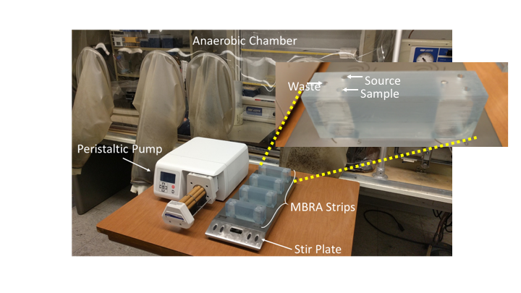

**Figure 6.** Picture of the Minibioreactor Array (MBRA) experimental set-up (shown outside anaerobic chamber for better clarity).

Bioreactor experiments will allow precisely controlled conditions under steady-state in which dilution rate (colonic transit time) can be monitored and controlled as well as nutrient input. We will utilize stereo-lithographed mini-bioreactors that are in wide use for *C. difficile* research53–55 (Fig. 6). The medium composition reflects nutrient components common in the GI tract (e.g. complex carbohydrates, mucin, conjugated bile acids). We will compare *C. difficile* levels and microbiome composition in bioreactors inoculated with identical stool sample +/- the competition microbe (probiotic) identified in Step 1.

Dynamic simulations subject to changing interaction topologies, such as we have here, are prone to parameter sensitivity. We will leverage multi’omics data generated by the mini-bioreactors to better assess these parameters across multiple levels of our simulations from reaction fluxes to microbe-microbe interactions56,57. These will allow us to better assess the true value of our parameters for improved simulation accuracy. Separate from these considerations, differences in population trajectories may arise from small variations in initial conditions. In order to address these differences, we will use the well-established technique of ensemble forecasting for assessing our species distributions58,59.

We expect at least 5 of the probiotics that we test to engraft and prevent *C. diff* infection within their paired microbiomes. This expectation is based on existing experimental data on engraftment which shows that 1/3 to 2/3 of bacteria engraft successfully10,19. Since we are selecting probiotics with potential to exclude *C. diff* from the gut, we expect to identify 5 bacteria capable of engrafting in their target microbiomes and preventing *C. diff* colonization—these will proceed to Step 3.

##### *Methods:-*

***Bioreactor setup***. Our minibioreactor arrays (MBRAs) mimic a previously reported model53 and will be maintained in a Coy Anaerobic chamber. As described previously, each strip consists of three duplicate bioreactors with a total internal volume of 50 ml and an operating volume of 20 to 30 ml, designed to mimic the conditions within the human gut. A semi-defined medium containing complex dietary carbohydrates (xylan, pectin, arabinogalactan, amylopectin) and host factors (porcin gastric mucin, bile salts), which has been validated for maintaining fecal microbiota60, constantly enters the strip (20 ml; pH 6.8) at a rate of 0.04 to 0.06 h-1, consistent with human colonic transit time MBRA strips will be maintained at 37°C, magnetically stirred, and maintained under an atmosphere of CO2. Two 12-channel peristaltic pumps will control the continuous flow of freshly made culture media and spent medium. The MBRA strips will be allowed to equilibrate for 14 days and will then be operated at a total retention time of 25 h, approximating that of the human GI tract60. ***Probiotic testing*.** For each microbiome-probiotic pair, four MBRA runs will be analyzed. Fresh frozen 20% (w/v) fecal slurry collected at Mayo Clinic will be added to six duplicate MMBR strips. To one strip (3 bioreactor chambers), we will add 107 CFU of the probiotic and the culture medium will be pumped at the dilution rate. Once steady state has been reached, which will require ~330 hrs, we will introduce *C. diff* into all six MBRAs at 106 CFU/ml or a 1:100 dilution of exponentially grown culture. The system will be run for 10 days following *C. diff* addition; on the 6th day. Sampling will occur pre-*C. diff* addition and on the 5th and 10th days post-addition. *C. diff* levels will be quantified at each time point with qPCR, as reported previously. In addition, the overall microbial communities present in the reactor will be assessed using 16S rDNA gene sequencing. A total of 10 bioreactor experiments will be run (5 probiotics, 10 MMBR strips (each strip contains 3 technical replicates; +/- probiotic will be compared in each experiment). A total of 1200 samples will be collected from 40 bioreactors (4 replicates across 10 experiments sampled 3 times each). All 120 will have their community profiles assessed by shallow metagenomics51 and quantitative metabolomics targeting amino acids, bile acids, and short-chain fatty acids (as described in PI’s previous work22,61). Metatranscriptomics will be assessed in one replicate of each bioreactor experiment from the samples taken immediate before and after *C. diff* addition.

**Dynamic FBA.** Briefly, for each of the 10 candidate microbiomes, starting conditions will be seeded by combining microbial composition data and *in vitro* media conditions sufficient for maintaining large intestine microbiota. Using known metabolic networks, we will model the dynamic response of the ecological community to perturbations including forced change in community composition. We can model these interactions by dynamic flux balance analysis (DFBA)40. DFBA is based on the basic assumption of constraint based metabolic modeling that the reaction fluxes of the internal metabolic network maximize growth of an organism (or possibly some other objective) while remaining at steady state. Therefore, if the biomass of organism $i$ is donated as $x_{i}$ and the concentration of external metabolite $j$ is denoted as $y_{j}$, then the growth of organism $i$ and resulting change in environmental metabolites can be modeled with the system of ordinary differential equations

$$\frac{dx_{i}}{dt}=x_{i} \left({\vec{w}}_{i}∙{\vec{γ}}_{i}\right)-d_{i}(x_{i},t)$$

$$\frac{d\vec{y}}{dt}= -x_{i}Γ_{i}^{1}\vec{w}+\vec{g}(t)$$

$$\frac{d{\vec{w}}_{i}}{dt}= f_{i}({\vec{w}}_{i},\vec{y})$$

where *di* gives the death rate of the organism, γi is the growth objective vector, Γi1 is a submatrix of the stoichiometric matrix Γi, *wi* is a vector of internal fluxes, *g* gives the inflow and outflow of nutrients, and *fi* is a function which enforces the optimization and steady state constraints on *wi*. Notably, the only parameters of this system not directly observed from the metabolic network are the uptake rate of each nutrient (which appears as a parameter in *fi*), the death (or depletion due to outflow) rate of the organism, and the flow function *g*. The function *g* is presumably known, while a simple proportional death rate is likely appropriate for *di*. There is then |*y*|+1 parameters to be estimated for a single organism model.

To model the community, we must account for the changes in vector *y* due to each species. The community model is the same as above for each *xi* and *wi*, while *y* instead evolves according to

$$\frac{d\vec{y}}{dt}= \vec{g}(t)-\sum{x_{i}Γ_{i}^{1}\vec{w}}$$

with the summation over the set of organisms present. We therefore must estimate (|*y*|+1)*|*x*| parameters.

For each set of starting conditions, species composition will be allowed to stabilize before further testing. The candidate probiotic for each simulation will be added in the amount of 0.1% of the microbial population, to reflect the administration of ~1010 CFU in the human gut (or ~109 in the murine gut) at a single time point. Using bacterial replication rates as our clock, we will run simulations for the equivalent of 2 months of biological time, to identify persisters. At the end of the engraftment period, we will introduce *C. diff* in the amount of 0.1% of the population to simulate a large exposure to the pathogen. A control for each simulation will be run using the stabilized microbiome without the addition of the probiotic addition, but with the same *C. diff* exposure. Results will be compared to identify probiotics that enhance *C. diff* resistance.

**Multi’omics Parameter Matching.** Metabolic modeling has many strengths, including its overall predictive power which includes ability to predict growth rates, metabolite uptake/secretion, and reaction fluxes. Conversely, the accuracy of metabolic modeling benefits from longitudinal microbial abundance data (~growth rates), metabolomics (~metabolite uptake/secretion), and metatranscriptomics (~reaction fluxes). In brief, we will identify reference genomes using metagenomics17, map metatranscriptomic reads to these reference genomes, and integrate gene expression information with the reaction fluxes in our metabolic models62 by optimizing parameters in *fi*. We will then take these enhanced models and consider parameters in community objective function γ that best reproduces the time-longitudinal community abundance profiles and metabolomics data by considering these surrogates of community flux to different biomasses in γ40,63,64.

**Ensemble Forecasting.** We will permute initial conditions in each model using a Gaussian noise distribution and use the distribution of trajectories from these permuted simulations to identify the predictions that are robust across simulations. These results will allow us to quantify the uncertainty associated with a prediction by taking a normalized sum of each outcome, thereby giving a measure of the probability that a probiotic will exhibit long-term persistence and prevent *C. diff* infection. This procedure will be repeated 10 times for each probiotic-microbiome combination to ensure that we obtain robust simulation results. This will yield important information about the sensitivity of various outcomes to minor differences and give us a means to assess the overall robustness of our predictions. If strong sensitivities, such as bimodality, manifest themselves, we will increase the number of simulations to quantify them. *In short, these dynamic simulations will allow us to differentiate between the ecologic dynamics of transient versus long-term engraftment and identify probiotics capable of preventing C. diff invasion.*

Step 3: ***Validate in silico predictions using a germ-free mouse model***.

In the last step of the pipeline, we will further test the 5 probiotics most effective at preventing *C. diff* infectionin Steps 1 and 2. Validation using an *in vivo* model will test the predictions of our static and dynamic computational models in a host environment, ensuring that our modeling parameters, such as temporal step size and update scheme, appropriately reflect physiologic conditions in the gut. Here, we will investigate the ability of specific probiotics to stabilize within an existing community by introducing them into an established fecal microbiome from a human host. We will also obtain results from a control group of mice without probiotics, to account for the natural differences that arise when introducing human microbiomes into germ-free mice. This design provides a stringent testing criterion for finalizing probiotic design. ***Probiotics that perform well during this step will have passed a rigorous 3-step test, and may be suitable for clinical testing.***

##### *Methods:-*

All mouse experiments will be performed with mice born and maintained in the Mayo Clinic Germ-free Facility, as described previously24,25 and presented in Fig. 7. To carry out this experiment, we will first humanize germ-free Swiss Webster mice by inoculating groups of 18 with one of the 5 *C. diff*-susceptible stool samples identified in Step 2 for further testing. At 4 weeks of age, a 300-μl fecal suspension will be gavaged into a group of 18 mice per test. Each test will consist of two arms, a probiotic testing group that will be given an oral gavage with a liquid culture with ~109 CFUs of probiotic at 8 weeks and 4 days later, and a control group that will be administered a sham, half of the mice will be subjected to oral gavage with a liquid culture of ~109 CFU of the probiotic being tested. At 10 weeks, the mice will be challenged with a 300-μl oral gavage containing *C. diff* strain 630 from an overnight liquid culture.

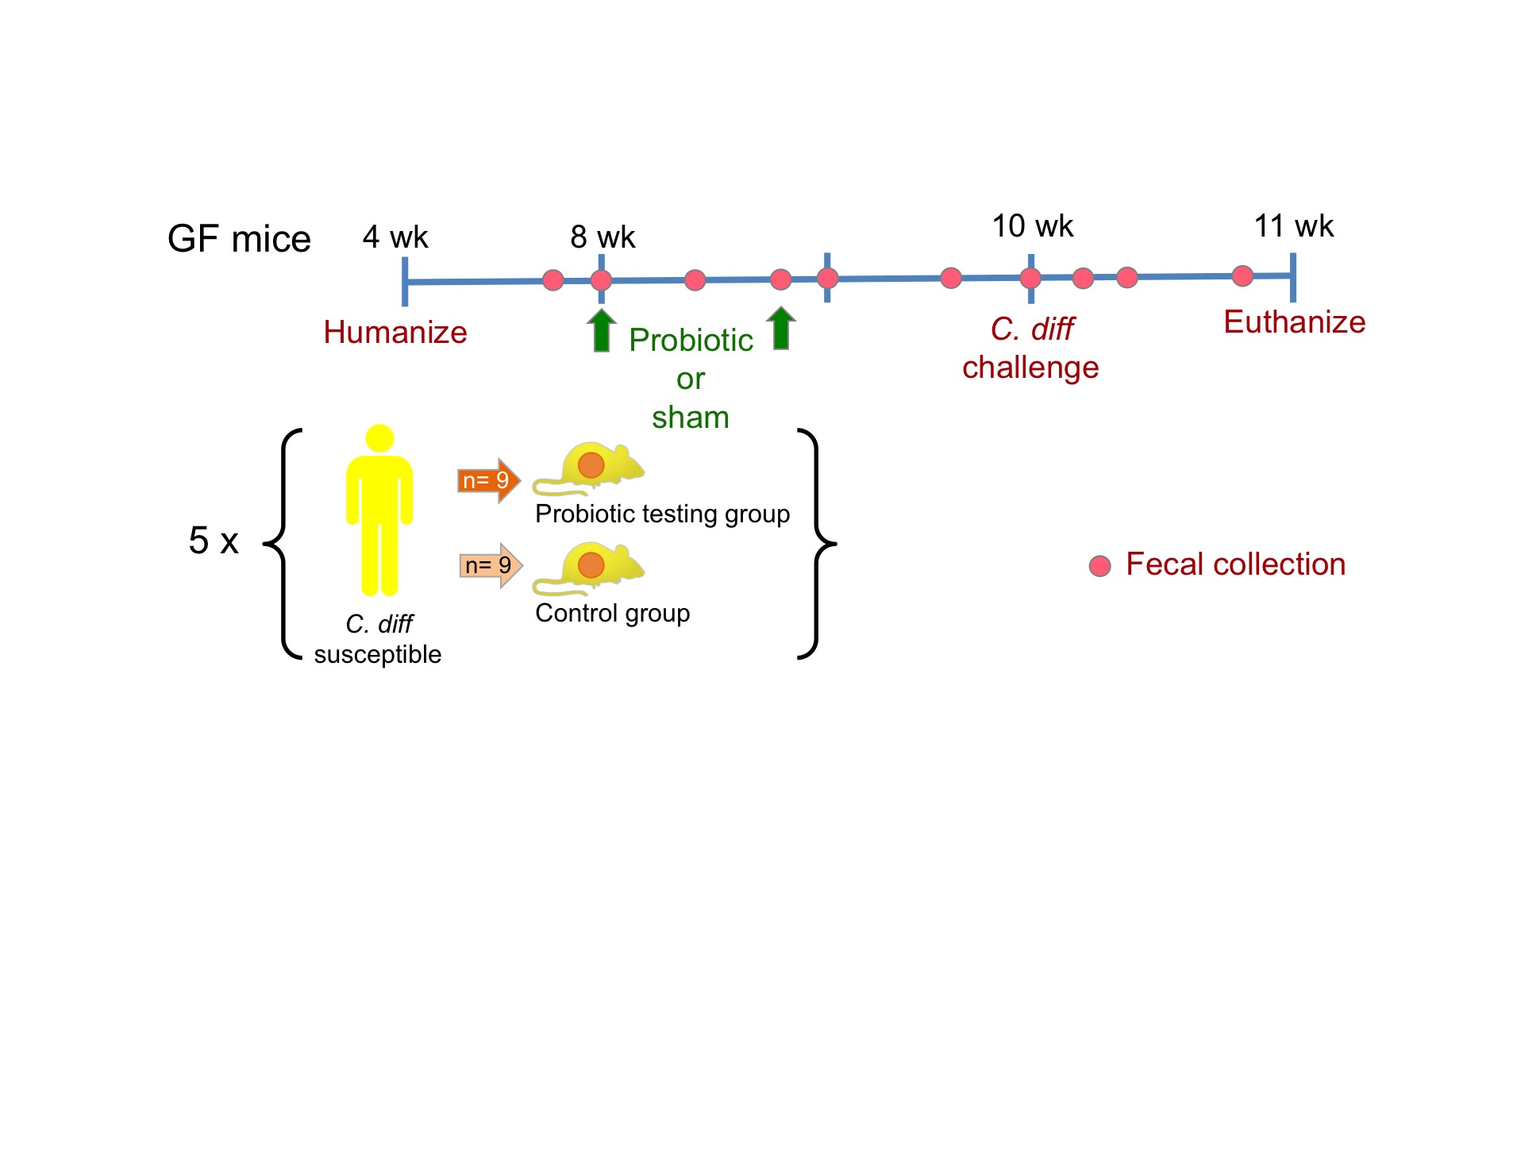

**Figure 7.** Schematic of germ-free mouse testing for Step 3.

In order to assess the probiotics’ long-term engraftment, fecal pellets will also be taken and shallow metagenomics sequencing and analysis will be performed, following the methods already described for Step 1. Fecal pellets collected post-infection will be used to quantify *C. diff* stool burden using a culture assay.

### Expected outcomes

When this research is complete, we expect to have produced a short list of promising probiotics whose potential to ward off *C. diff* infection can then be tested in clinical trials, whether adaptive, aggregated *N*-of-1, or conventional. In a trial setting, a candidate probiotic could be administered to a patient who has undergone antibiotic therapy in a hospital setting and is vulnerable to infection. If that probiotic proves effective for *C. diff* prevention, it may also warrant testing for treatment of established infections. More broadly, though, we expect the proposed pipeline to open up new vistas in probiotic design by (1) giving researchers a tool to systematically evaluate the potential of all cultivated microbes to achieve a target microbiome, and thus prevent or eliminate deleterious health conditions, and (2) providing personalized solutions that allow patients with different starting microbiome profiles to achieve the same healthy profile.

### Potential problems & alternative approaches

Our preliminary experiments indicate that our approach adequately reflects the biological and ecological realities driving *C. diff* infection. Indeed, *C. diff* infection was chosen as the subject of this study precisely because it is a disease largely driven by ecologic processes, and ours is an ecologic approach. Although we have designed our experiment to minimize potential issues, we recognize that problems may arise. One of the most significant issues we anticipate will be the ability of our multiscale models to capture the biology necessary for accurate predictions.

*What about non-metabolic interactions, such as the signaling pathways of C. diff?* Many known and unknown signaling pathways exist that can affect the growth of a microbial species. *C. diff,* in particular,has many well-identified signaling pathways and growth activators and inhibitors. Our preliminary results suggest that metabolic models suffice for predicting overall growth. Nonetheless, we have included time-longitudinal sampling from stool bioreactor experiments as a means of looking more closely to identify key microbe-microbe or microbe-metabolite interactions.

*What if a probiotic fails to engraft in your germ-free mouse model*? To maximize chances of engraftment, standard practice is to administer probiotics along with the starting microbial community during the process of humanization. However, to better simulate conditions that might be encountered in the clinic, we plan to administer probiotics after humanization; this will allow us to test the ability of specific probiotics to engraft in already established communities. In the previous steps of the pipeline, we have intentionally selected microbes for their ability to grow and persist in the gut community; therefore, we do not anticipate problems with engraftment. However, if we do encounter such problems, we will try administering the probiotic at the beginning of the humanization process, in accordance with standard practice in the field.

*Our current regulatory system is not set up to facilitate the use of personalized therapies. How will this pipeline be implemented in the real world?* In response to the Precision Medicine Initiative, the US Food & Drug Administration is already changing its practices to facilitate the testing and approval of personalized therapies. The recently approved 21st Century Cures Act, for example, will result in many changes to the way drug and medical device applications are processed, speeding the approval process so that patients have access to novel, personalized treatments sooner.

**Projected Timeline**

|  |  |  |  |  |  |  |  |  |  |  |
| --- | --- | --- | --- | --- | --- | --- | --- | --- | --- | --- |
| Task | Year 1 | | Year 2 | | Year 3 | | Year 4 | | Year 5 | |
| Step 1: |  |  |  |  |  |  |  |  |  |  |
| -*C. diff* interaction |  |  |  |  |  |  |  |  |  |  |
| -Engraftment score |  |  |  |  |  |  |  |  |  |  |
| Step 2: |  |  |  |  |  |  |  |  |  |  |
| -Stool Bioreactor Setup |  |  |  |  |  |  |  |  |  |  |
| -Stool Bioreactor Experiment |  |  |  |  |  |  |  |  |  |  |
| -Dynamic FBA Simulation |  |  |  |  |  |  |  |  |  |  |
| -Multi’omics Data Integration |  |  |  |  |  |  |  |  |  |  |
| Step 3: Germ-free Mouse Testing |  |  |  |  |  |  |  |  |  |  |

## REFERENCES

1. Allen SJ, Okoko B, Martinez EG, Gregorio G V, Dans LF. Probiotics for treating infectious diarrhoea. Cochrane Database Syst Rev. 2003. PMID: 21069673

2. Sazawal S, Hiremath G, Dhingra U, Malik P, Deb S, Black RE. Efficacy of probiotics in prevention of acute diarrhoea: a meta-analysis of masked, randomised, placebo-controlled trials. Lancet Infectious Diseases. 2006. PMID: 16728323

3. Goldenberg JZ, Ma SSY, Saxton JD, Martzen MR, Vandvik PO, Thorlund K, Guyatt GH, Johnston BC. Probiotics for the prevention of Clostridium difficile-associated diarrhea in adults and children. Cochrane Database of Systematic Reviews. 2013. PMID: 23728658

4. Österlund P, Ruotsalainen T, Korpela R, Saxelin M, Ollus A, Valta P, Kouri M, Elomaa I, Joensuu H. Lactobacillus supplementation for diarrhoea related to chemotherapy of colorectal cancer: A randomised study. Br J Cancer. 2007; PMID: 17895895

5. Mego M, Chovanec J, Vochyanova-Andrezalova I, Konkolovsky P, Mikulova M, Reckova M, Miskovska V, Bystricky B, Beniak J, Medvecova L, Lagin A, Svetlovska D, Spanik S, Zajac V, Mardiak J, Drgona L. Prevention of irinotecan induced diarrhea by probiotics: A randomized double blind, placebo controlled pilot study. Complement Ther Med. 2015; PMID: 26051570

6. Routy B, Le Chatelier E, Derosa L, Duong CPM, Alou MT, Daillère R, Fluckiger A, Messaoudene M, Rauber C, Roberti MP, Fidelle M, Flament C, Poirier-Colame V, Opolon P, Klein C, Iribarren K, Mondragón L, Jacquelot N, Qu B, Ferrere G, Clémenson C, Mezquita L, Masip JR, Naltet C, Brosseau S, Kaderbhai C, Richard C, Rizvi H, Levenez F, Galleron N, Quinquis B, Pons N, Ryffel B, Minard-Colin V, Gonin P, Soria JC, Deutsch E, Loriot Y, Ghiringhelli F, Zalcman G, Goldwasser F, Escudier B, Hellmann MD, Eggermont A, Raoult D, Albiges L, Kroemer G, Zitvogel L. Gut microbiome influences efficacy of PD-1-based immunotherapy against epithelial tumors. Science (80- ). 2018; PMID: 29097494

7. Matson V, Fessler J, Bao R, Chongsuwat T, Zha Y, Alegre ML, Luke JJ, Gajewski TF. The commensal microbiome is associated with anti-PD-1 efficacy in metastatic melanoma patients. Science (80- ). 2018; PMID: 29302014

8. Gopalakrishnan V, Spencer CN, Nezi L, Reuben A, Andrews MC, Karpinets T V., Prieto PA, Vicente D, Hoffman K, Wei SC, Cogdill AP, Zhao L, Hudgens CW, Hutchinson DS, Manzo T, Petaccia De Macedo M, Cotechini T, Kumar T, Chen WS, Reddy SM, Szczepaniak Sloane R, Galloway-Pena J, Jiang H, Chen PL, Shpall EJ, Rezvani K, Alousi AM, Chemaly RF, Shelburne S, Vence LM, Okhuysen PC, Jensen VB, Swennes AG, McAllister F, Marcelo Riquelme Sanchez E, Zhang Y, Le Chatelier E, Zitvogel L, Pons N, Austin-Breneman JL, Haydu LE, Burton EM, Gardner JM, Sirmans E, Hu J, Lazar AJ, Tsujikawa T, Diab A, Tawbi H, Glitza IC, Hwu WJ, Patel SP, Woodman SE, Amaria RN, Davies MA, Gershenwald JE, Hwu P, Lee JE, Zhang J, Coussens LM, Cooper ZA, Futreal PA, Daniel CR, Ajami NJ, Petrosino JF, Tetzlaff MT, Sharma P, Allison JP, Jenq RR, Wargo JA. Gut microbiome modulates response to anti-PD-1 immunotherapy in melanoma patients. Science (80- ). 2018; PMID: 29097493

9. Chaput N, Lepage P, Coutzac C, Soularue E, Le Roux K, Monot C, Boselli L, Routier E, Cassard L, Collins M, Vaysse T, Marthey L, Eggermont A, Asvatourian V, Lanoy E, Mateus C, Robert C, Carbonnel F. Baseline gut microbiota predicts clinical response and colitis in metastatic melanoma patients treated with ipilimumab. Ann Oncol. 2017; PMID: 28368458

10. Maldonado-Gómez MX, Martínez I, Bottacini F, O’Callaghan A, Ventura M, van Sinderen D, Hillmann B, Vangay P, Knights D, Hutkins RW, Walter J. Stable Engraftment of Bifidobacterium longum AH1206 in the Human Gut Depends on Individualized Features of the Resident Microbiome. Cell Host Microbe. 2016; PMID: 27693307

11. Kelly JR, Allen AP, Temko A, Hutch W, Kennedy PJ, Farid N, Murphy E, Boylan G, Bienenstock J, Cryan JF, Clarke G, Dinan TG. Lost in translation? The potential psychobiotic Lactobacillus rhamnosus (JB-1) fails to modulate stress or cognitive performance in healthy male subjects. Brain Behav Immun. 2017; PMID: 27865949

12. Zmora N, Zilberman-Schapira G, Suez J, Mor U, Dori-Bachash M, Bashiardes S, Kotler E, Zur M, Regev-Lehavi D, Brik RBZ, Federici S, Cohen Y, Linevsky R, Rothschild D, Moor AE, Ben-Moshe S, Harmelin A, Itzkovitz S, Maharshak N, Shibolet O, Shapiro H, Pevsner-Fischer M, Sharon I, Halpern Z, Segal E, Elinav E. Personalized Gut Mucosal Colonization Resistance to Empiric Probiotics Is Associated with Unique Host and Microbiome Features. Cell. 2018; PMID: 30193112

13. Walter J, Maldonado-Gómez MX, Martínez I. To engraft or not to engraft: an ecological framework for gut microbiome modulation with live microbes. Current Opinion in Biotechnology. 2018. PMID: 28866242

14. Coyte KZ, Schluter J, Foster KR. The ecology of the microbiome: Networks, competition, and stability. Science (80- ). 2015;350(6261):663–666. PMID: 26542567

15. Hale VL, Jeraldo P, Mundy M, Yao J, Keeney G, Scott N, Heidi Cheek E, Davidson J, Green M, Martinez C, Lehman J, Pettry C, Reed E, Lyke K, White BA, Diener C, Resendis-Antonio O, Gransee J, Dutta T, Petterson X-M, Boardman L, Larson D, Nelson H, Chia N. Synthesis of multi-omic data and community metabolic models reveals insights into the role of hydrogen sulfide in colon cancer. Methods [Internet]. 2018 Apr; Available from: http://linkinghub.elsevier.com/retrieve/pii/S104620231730436X PMID: 29704665

16. Benedict MN, Mundy MB, Henry CS, Chia N, Price ND. Likelihood-Based Gene Annotations for Gap Filling and Quality Assessment in Genome-Scale Metabolic Models. PLoS Comput Biol. 2014;10(10). PMID: 25329157

17. Mendes-Soares H, Mundy M, Soares LM, Chia N. MMinte: An application for predicting metabolic interactions among the microbial species in a community. BMC Bioinformatics. 2016;17(1).

18. Mundy M, Mendes-Soares H, Chia N. Mackinac: a bridge between ModelSEED and COBRApy to generate and analyze genome-scale metabolic models. Bioinformatics [Internet]. 2017 Aug 1;33(15):2416–2418. Available from: http://www.ncbi.nlm.nih.gov/pubmed/28379466 PMID: 28379466

19. Martínez I, Maldonado-Gomez MX, Gomes-Neto JC, Kittana H, Ding H, Schmaltz R, Joglekar P, Cardona RJ, Marsteller NL, Kembel SW, Benson AK, Peterson DA, Ramer-Tait AE, Walter J. Experimental evaluation of the importance of colonization history in early-life gut microbiota assembly. Elife. 2018; PMID: 30226190

20. Seto CT, Jeraldo P, Orenstein R, Chia N, DiBaise JK. Prolonged use of a proton pump inhibitor reduces microbial diversity: Implications for Clostridium difficile susceptibility. Microbiome. 2014;2(1).

21. Chia N, Goldenfeld N. Statistical Mechanics of Horizontal Gene Transfer in Evolutionary Ecology. Journal of Statistical Physics. 2011. p. 1287–1301.

22. Hale VL, Jeraldo P, Chen J, Mundy M, Yao J, Priya S, Keeney G, Lyke K, Ridlon J, White BA, French AJ, Thibodeau SN, Diener C, Resendis-Antonio O, Gransee J, Dutta T, Petterson X-MT, Blekhman R, Boardman L, Larson D, Nelson H, Chia N, Sung J, Blekhman R, Boardman L, Larson D, Nelson H, Chia N. Distinct Microbes, Metabolites, and Ecologies Define the Microbiome in Deficient and Proficient Mismatch Repair Colorectal Cancers. Genome Med [Internet]. 2018 Jan 1;10(1):78. Available from: https://genomemedicine.biomedcentral.com/articles/10.1186/s13073-018-0586-6

23. Mendes-Soares H, Chia N. Community metabolic modeling approaches to understanding the gut microbiome: Bridging biochemistry and ecology. Free Radic Biol Med [Internet]. 2017;105:102–109. Available from: http://www.ncbi.nlm.nih.gov/pubmed/27989793 PMCID: PMC5401773

24. Battaglioli EJ, Hale VL, Chen J, Jeraldo P, Ruiz-Mojica C, Schmidt BA, Rekdal VM, Till LM, Huq L, Smits SA, Moor WJ, Jones-Hall Y, Smyrk T, Khanna S, Pardi DS, Grover M, Patel R, Chia N, Nelson H, Sonnenburg JL, Farrugia G, Kashyap PC. Clostridioides difficile uses amino acids associated with gut microbial dysbiosis in a subset of patients with diarrhea. Sci Transl Med. 2018; PMID: 30355801

25. Battaglioli E, Hale V, Chen J, Jeraldo P, Rekdal VM, Huq L, Smits SA, Smyrk T, Khanna S, Pardi DS. Prophylactic Fecal Microbial Transplant Restores Clostridium Difficile Colonization Resistance in a Dysbiotic Subset of Diarrhea Associated Human Microbial Communities Modeled in Germ Free Mice. Gastroenterology. 2017;152(5):S348.

26. Sung J, Kim S, Cabatbat JJT, Jang S, Jin Y-S, Jung GY, Chia N, Kim P-J. Global metabolic interaction network of the human gut microbiota for context-specific community-scale analysis. Nat Commun [Internet]. 2017 Jun 6;8:15393. Available from: http://www.ncbi.nlm.nih.gov/pubmed/28585563 PMCID: PMC5467172

27. Magnúsdóttir S, Heinken A, Kutt L, Ravcheev DA, Bauer E, Noronha A, Greenhalgh K, Jäger C, Baginska J, Wilmes P, Fleming RMT, Thiele I. Generation of genome-scale metabolic reconstructions for 773 members of the human gut microbiota. Nat Biotechnol. 2017;35(1):81–89. PMID: 27893703

28. Dejea CM, Fathi P, Craig JM, Boleij A, Taddese R, Geis AL, Wu X, DeStefano Shields CE, Hechenbleikner EM, Huso DL, Anders RA, Giardiello FM, Wick EC, Wang H, Wu S, Pardoll DM, Housseau F, Sears CL. Patients with familial adenomatous polyposis harbor colonic biofilms containing tumorigenic bacteria. Science (80- ). 2018;359(6375):592–597. PMID: 29420293

29. Housseau F, Sears CL. Enterotoxigenic Bacteroides fragilis (ETBF)-mediated colitis in Min (Apc+/-) mice: A human commensal-based murine model of colon carcinogenesis. Cell Cycle. 2010;9(1):3–5. PMID: 20009569

30. Mima K, Nishihara R, Qian ZR, Cao Y, Sukawa Y, Nowak JA, Yang J, Dou R, Masugi Y, Song M, Kostic AD, Giannakis M, Bullman S, Milner DA, Baba H, Giovannucci EL, Garraway LA, Freeman GJ, Dranoff G, Garrett WS, Huttenhower C, Meyerson M, Meyerhardt JA, Chan AT, Fuchs CS, Ogino S. Fusobacterium nucleatum in colorectal carcinoma tissue and patient prognosis. Gut. 2016;65(12):1973–1980. PMID: 26311717

31. Kostic AD, Chun E, Robertson L, Glickman JN, Gallini CA, Michaud M, Clancy TE, Chung DC, Lochhead P, Hold GL, El-Omar EM, Brenner D, Fuchs CS, Meyerson M, Garrett WS. Fusobacterium nucleatum Potentiates Intestinal Tumorigenesis and Modulates the Tumor-Immune Microenvironment. Cell Host Microbe. 2013;14(2):207–215. PMID: 23954159

32. NIH. Probiotics: In Depth. https://nccih.nih.gov/health/probiotics/introduction.htm.

33. Turnbaugh PJ, Ley RE, Mahowald MA, Magrini V, Mardis ER, Gordon JI. An obesity-associated gut microbiome with increased capacity for energy harvest. Nature. 2006; PMID: 17183312

34. Wen L, Ley RE, Volchkov PY, Stranges PB, Avanesyan L, Stonebraker AC, Hu C, Wong FS, Szot GL, Bluestone JA, Gordon JI, Chervonsky A V. Innate immunity and intestinal microbiota in the development of Type 1 diabetes. Nature. 2008; PMID: 18806780

35. Sampson TR, Debelius JW, Thron T, Janssen S, Shastri GG, Ilhan ZE, Challis C, Schretter CE, Rocha S, Gradinaru V, Chesselet MF, Keshavarzian A, Shannon KM, Krajmalnik-Brown R, Wittung-Stafshede P, Knight R, Mazmanian SK. Gut Microbiota Regulate Motor Deficits and Neuroinflammation in a Model of Parkinson’s Disease. Cell. 2016; PMID: 27912057

36. Arthur JC, Perez-Chanona E, Mühlbauer M, Tomkovich S, Uronis JM, Fan TJ, Campbell BJ, Abujamel T, Dogan B, Rogers AB, Rhodes JM, Stintzi A, Simpson KW, Hansen JJ, Keku TO, Fodor AA, Jobin C. Intestinal inflammation targets cancer-inducing activity of the microbiota. Science (80- ). 2012; PMID: 22903521

37. Kristensen NB, Bryrup T, Allin KH, Nielsen T, Hansen TH, Pedersen O. Alterations in fecal microbiota composition by probiotic supplementation in healthy adults: A systematic review of randomized controlled trials. Genome Med. 2016; PMID: 27159972

38. Wroblewski LE, Peek RM, Wilson KT. Helicobacter pylori and gastric cancer: Factors that modulate disease risk. Clinical Microbiology Reviews. 2010. PMID: 20930071

39. Geller LT, Barzily-Rokni M, Danino T, Jonas OH, Shental N, Nejman D, Gavert N, Zwang Y, Cooper ZA, Shee K, Thaiss CA, Reuben A, Livny J, Avraham R, Frederick DT, Ligorio M, Chatman K, Johnston SE, Mosher CM, Brandis A, Fuks G, Gurbatri C, Gopalakrishnan V, Kim M, Hurd MW, Katz M, Fleming J, Maitra A, Smith DA, Skalak M, Bu J, Michaud M, Trauger SA, Barshack I, Golan T, Sandbank J, Flaherty KT, Mandinova A, Garrett WS, Thayer SP, Ferrone CR, Huttenhower C, Bhatia SN, Gevers D, Wargo JA, Golub TR, Straussman R. Potential role of intratumor bacteria in mediating tumor resistance to the chemotherapeutic drug gemcitabine. Science (80- ). 2017; PMID: 28912244

40. Zomorrodi AR, Islam MM, Maranas CD. D-OptCom: Dynamic Multi-level and Multi-objective Metabolic Modeling of Microbial Communities. ACS Synth Biol. 2014; PMID: 24742179

41. Freter R, Brickner H, Botney M, Cleven D, Aranki A. Mechanisms that control bacterial populations in continuous-flow culture models of mouse large intestinal flora. Infect Immun. 1983; PMID: 6339388

42. Kearney SM, Gibbons SM, Erdman SE, Alm EJ. Orthogonal Dietary Niche Enables Reversible Engraftment of a Gut Bacterial Commensal. Cell Rep. 2018; PMID: 30110640

43. Pereira FC, Berry D. Microbial nutrient niches in the gut. Environmental Microbiology. 2017. PMID: 28035742

44. Freter R, Brickner H, Fekete J, Vickerman MM, Carey KE. Survival and implantation of Escherichia coli in the intestinal tract. Infect Immun. 1983; PMID: 6339389

45. Ng KM, Ferreyra JA, Higginbottom SK, Lynch JB, Kashyap PC, Gopinath S, Naidu N, Choudhury B, Weimer BC, Monack DM, Sonnenburg JL. Microbiota-liberated host sugars facilitate post-antibiotic expansion of enteric pathogens. Nature. 2013; PMID: 23995682

46. Pacheco AR, Munera D, Waldor MK, Sperandio V, Ritchie JM. Fucose sensing regulates bacterial intestinal colonization. Nature. 2012. PMID: 23160491

47. Deriu E, Liu JZ, Pezeshki M, Edwards RA, Ochoa RJ, Contreras H, Libby SJ, Fang FC, Raffatellu M. Probiotic bacteria reduce salmonella typhimurium intestinal colonization by competing for iron. Cell Host Microbe. 2013; PMID: 23870311

48. Gibson TE, Bashan A, Cao HT, Weiss ST, Liu YY. On the Origins and Control of Community Types in the Human Microbiome. PLoS Comput Biol. 2016; PMID: 26866806

49. Hale VL, Chen J, Johnson S, Harrington SC, Yab TC, Smyrk TC, Nelson H, Boardman LA, Druliner BR, Levin TR, Rex DK, Ahnen DJ, Lance P, Ahlquist DA, Chia N. Shifts in the fecal microbiota associated with adenomatous polyps. Cancer Epidemiol Biomarkers Prev. 2017;26(1).

50. Sinha R, Chen J, Amir A, Vogtmann E, Shi J, Inman KS, Flores R, Sampson J, Knight R, Chia N. Collecting fecal samples for microbiome analyses in epidemiology studies. Cancer Epidemiol Biomarkers Prev. 2016;25(2).

51. Hillmann B, Al-Ghalith GA, Shields-Cutler RR, Zhu Q, Gohl DM, Beckman KB, Knight R, Knights D. Evaluating the Information Content of Shallow Shotgun Metagenomics. mSystems. 2018; PMID: 29634682

52. Truong DT, Franzosa EA, Tickle TL, Scholz M, Weingart G, Pasolli E, Tett A, Huttenhower C, Segata N. MetaPhlAn2 for enhanced metagenomic taxonomic profiling. Nat Methods. 2015; PMID: 26418763

53. Auchtung JM, Robinson CD, Britton RA. Cultivation of stable, reproducible microbial communities from different fecal donors using minibioreactor arrays (MBRAs). Microbiome. 2015;3(1):42.

54. Auchtung JM, Robinson CD, Farrell K, Britton RA. MiniBioReactor Arrays (MBRAs) as a Tool for Studying C. difficile Physiology in the Presence of a Complex Community. Methods Mol Biol [Internet]. 2016;1476:235–58. Available from: http://www.ncbi.nlm.nih.gov/pubmed/27507346 PMID: 27507346

55. Spinler JK, Auchtung J, Brown A, Boonma P, Oezguen N, Ross CL, Luna RA, Runge J, Versalovic J, Peniche A, Dann SM, Britton RA, Haag A, Savidge TC. Nextgeneration probiotics targeting Clostridium difficile through precursor-directed antimicrobial biosynthesis. Infect Immun. 2017; PMID: 28760934

56. Saha R, Chowdhury A, Maranas CD. Recent advances in the reconstruction of metabolic models and integration of omics data. Current Opinion in Biotechnology. 2014. PMID: 24632194

57. Sung J, Hale V, Merkel AC, Kim PJ, Chia N. Metabolic modeling with Big Data and the gut microbiome. Applied and Translational Genomics. 2016. p. 10–15. PMID: 27668170

58. Araújo MB, New M. Ensemble forecasting of species distributions. Trends in Ecology and Evolution. 2007. PMID: 17011070

59. Gneiting T, Raftery AE. Weather forecasting with ensemble methods. Science. 2005. PMID: 16224011

60. Macfarlane GT, Macfarlane S, Gibson GR. Validation of a three-stage compound continuous culture system for investigating the effect of retention time on the ecology and metabolism of bacteria in the human colon. Microb Ecol. 1998;35(2):180–187.

61. Hale VL, Jeraldo P, Mundy M, Yao J, Keeney G, Scott N, Cheek EH, Davidson J, Green M, Martinez C, Lehman J, Pettry C, Reed E, Lyke K, White BA, Diener C, Resendis-Antonio O, Gransee J, Dutta T, Petterson X-M, Boardman L, Larson D, Nelson H, Chia N. Synthesis of multi-omic data and community metabolic models reveals insights into the role of hydrogen sulfide in colon cancer. Methods. 2018;

62. Machado D, Herrgård M. Systematic Evaluation of Methods for Integration of Transcriptomic Data into Constraint-Based Models of Metabolism. PLoS Comput Biol. 2014; PMID: 24762745

63. Burgard AP, Maranas CD. Optimization-based framework for inferring and testing hypothesized metabolic objective functions. Biotechnol Bioeng. 2003; PMID: 12673766

64. Zomorrodi AR, Maranas CD. OptCom: A multi-level optimization framework for the metabolic modeling and analysis of microbial communities. PLoS Comput Biol. 2012; PMID: 22319433